**NAME : SAURABH SANTOSH PATIL**

**PRN : 2020BTECS00031**

**BATCH : S3**

**SUB:COA lab**

**< PRACTICAL no.10 >**

**Title of experiment**:

Largest and smallest number in an array of data

**Equipments required**:

**Gnu simulator**

**Theory:**

**Algorithm:- For only smallest number**

1. **Load the address of the first element of the array in HL pair.  
   2. Move the count to B - reg.  
   3. Increment the pointer.  
   4. Get the first data in A - reg.  
   5. Decrement the count.  
   6. Increment the pointer.  
   7. Compare the content of memory addressed by HL pair with that of A - reg.  
   8. If carry = 1, go to step 10 or if Carry = 0 go to step 9.  
   9. Move the content of memory addressed by HL to A - reg.  
   10. Decrement the count.  
   11. Check for Zero of the count. If ZF = 0, go to step 6, or if ZF = 1 go to next step.  
   12. Store the smallest data in memory.  
   13. Terminate the program.**

**Algorithm:-For largest number**

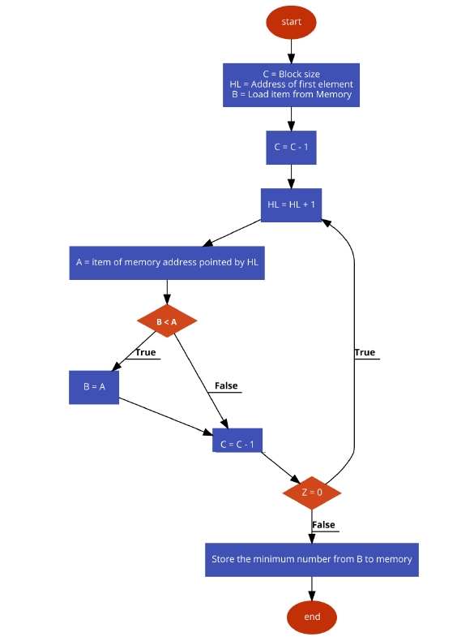

**Program code:**

**;smallest of n numbers**

**LXI H,1100**

**MOV C,M**

**INX H**

**DCR C**

**MOV A,M**

**loop: INX H**

**CMP M**

**JC skip**

**MOV A,M**

**skip: DCR C**

**JNZ loop**

**STA 1108**

**HLT**

**;largest of n numbers**

**LXI H,1100**

**MOV C,M**

**INX H**

**DCR C**

**MOV A,M**

**loop: INX H**

**CMP M**

**JNC skip**

**MOV A,M**

**skip: DCR C**

**JNZ loop**

**STA 1109**

**HLT**

**Snapshots:-**

**For smallest one:-**

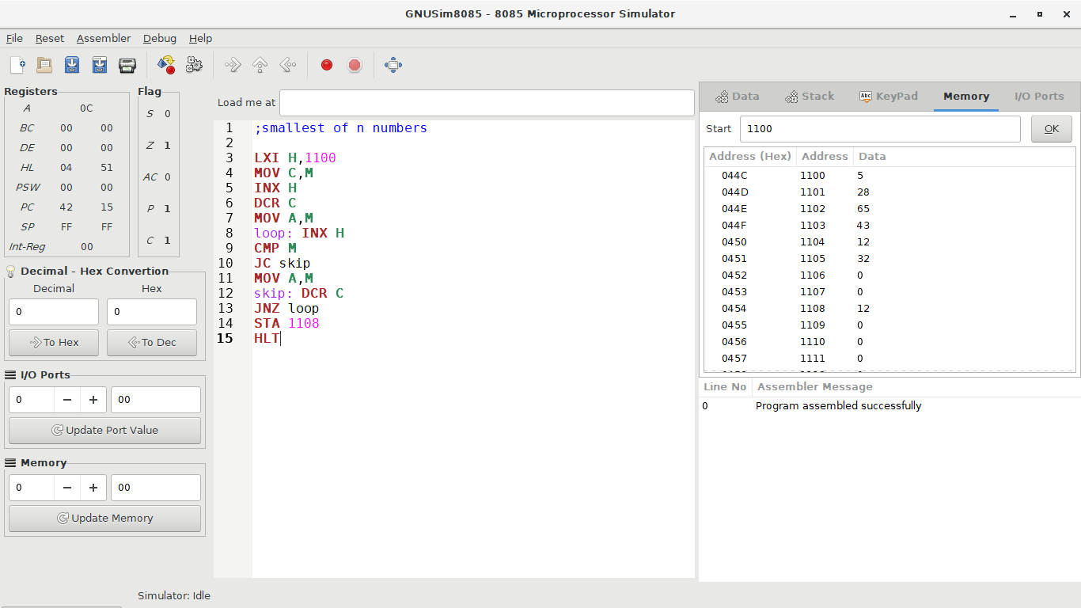

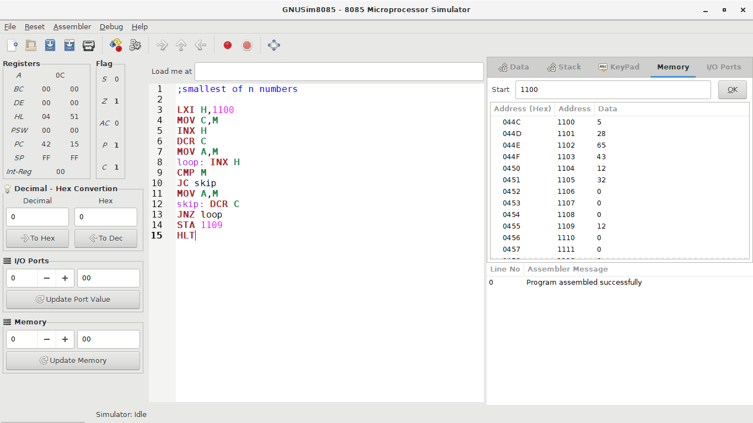

**For greatest one:-**

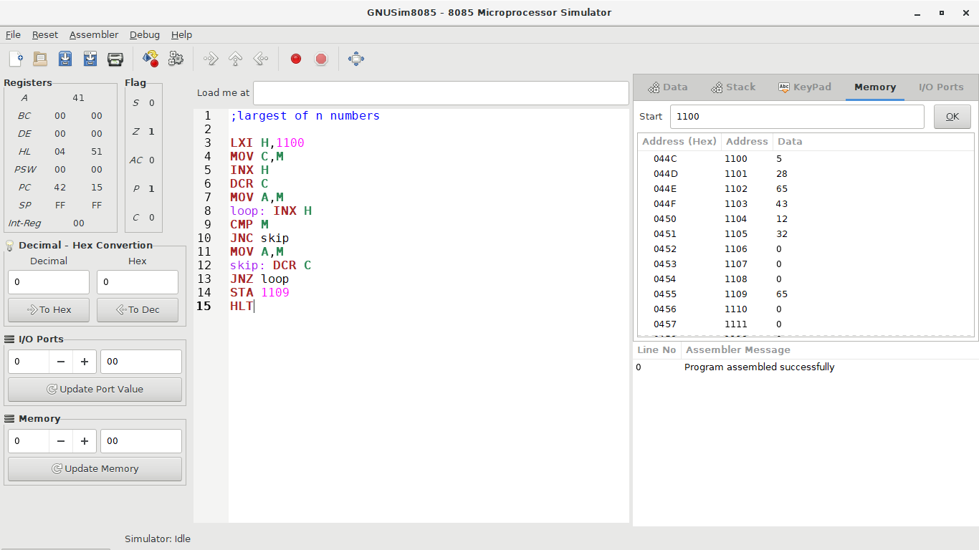

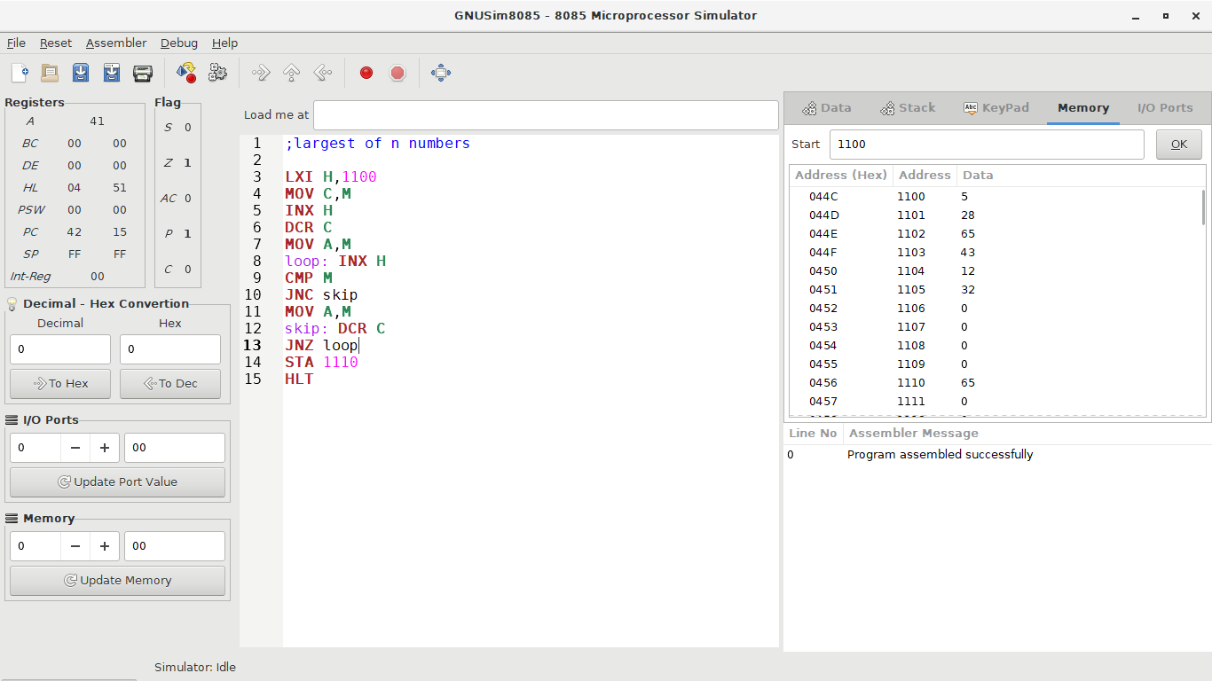

**Conclusions:**

**These are ways to design subtractor and comparator in Proteus**